**AIM:** Design DFA using simulator to accept even number of c’s over the set {a,b,c}

**INPUT:**

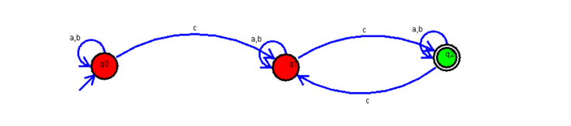

**OUTPUT:**

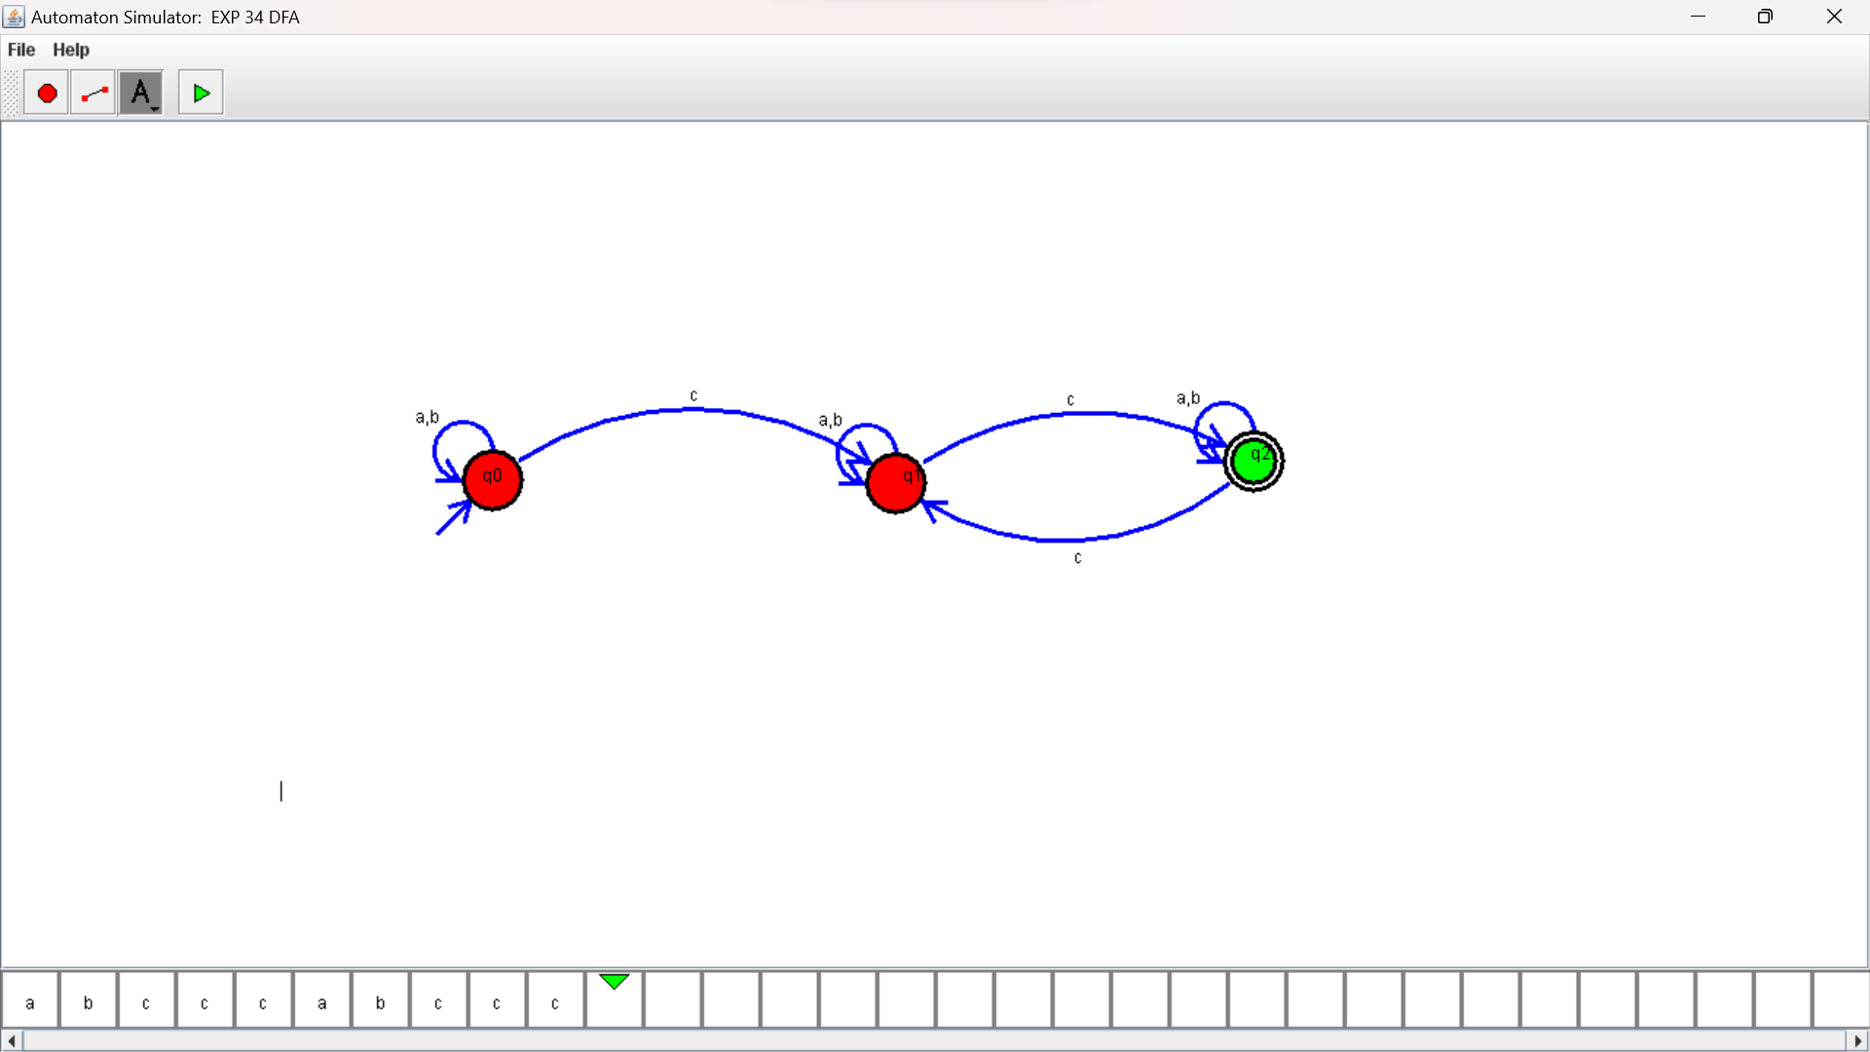

**RESULTS:**

DFA using simulator to accept even number of c’s over the set {a,b,c}